[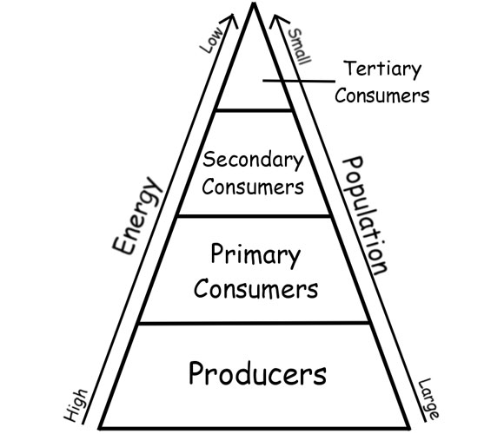](http://www.google.com/url?sa=i&rct=j&q=&esrc=s&source=images&cd=&cad=rja&uact=8&ved=0CAcQjRxqFQoTCMPi_qzGt8cCFULKPgodUkgPzA&url=http://fitz-brown14.wikis.birmingham.k12.mi.us/Populations%2B%26%2BEcosystems&ei=97jVVYOLI8KU-wHSkL3gDA&bvm=bv.99804247,d.dmo&psig=AFQjCNEPgGhZE06jkGBmoTtusRdcnXQoLg&ust=1440156198374848)

[](http://www.google.com/url?sa=i&rct=j&q=&esrc=s&source=images&cd=&cad=rja&uact=8&ved=0CAcQjRxqFQoTCMPi_qzGt8cCFULKPgodUkgPzA&url=http://fitz-brown14.wikis.birmingham.k12.mi.us/Populations%2B%26%2BEcosystems&ei=97jVVYOLI8KU-wHSkL3gDA&bvm=bv.99804247,d.dmo&psig=AFQjCNEPgGhZE06jkGBmoTtusRdcnXQoLg&ust=1440156198374848)