Lab Safety Drawing[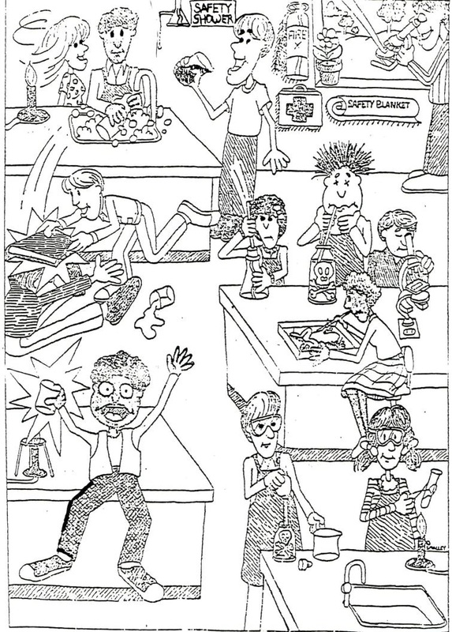](http://www.google.com/url?sa=i&rct=j&q=&esrc=s&source=images&cd=&cad=rja&uact=8&ved=0ahUKEwi1_ff85rvOAhVL6SYKHRZfDXUQjRwIBw&url=http://wghsjuniorscience.weebly.com/safety.html&psig=AFQjCNHn9cXe81_qbzLHImlQG_QKC6q_Ew&ust=1471088798264778)