STUDENT’S PACKET FOR THE WESLEY SCIENCE FAIR PROJECT

NAME:

GRADE:

TEACHER:

Science Fair Due Dates

All assignments for Science Fair are to be submitted via Google Classroom. Students should not turn in paper copies of any Science Fair document to their teachers. Teachers will monitor and give feedback on assignment completion.

Check Point 1- Topics Due via Google Classroom- August 24, 2018

- Teachers must approve student’s topics! Make sure they are asking an ORIGINAL question that can be answered through experimentation using the scientific method.
- No Science Buddies Topics- All topics should be original!

Check Point 2- Project Title, Purpose, and Hypothesis Due via Google Classroom- September 7, 2018

- Make sure Hypothesis follows a if/then statement format

Check Point 3- Materials & Procedures Due via Google Classroom- September 28, 2018

- Students it is critical for you to figure out which supplies are need and create a procedure as experimentation could take weeks. You will need to give parents enough time to purchase supplies.
- Items should be listed in bullet points (materials) and numbers (procedure)
- Make sure that as you are conducting the experiment you are also documenting data & results and taking photos of your project.
- October should be used for experimentation and collecting data!

Check Point 4- Results and Conclusion Due via Google Classroom- November 2, 2018

- Results should be in the form of a line, bar, or pie graph

Check Point 5- Research Paper Due via Google Classroom- November 16, 2018

Check Point 6- Written Report Due Via Google Classroom- December 3, 2018

Project Presentation- Science Fair Boards Due- December 5, 2018
HOW TO GET STARTED
1. Choose a topic. Be sure it interests you. Don’t pick one because you think it will be easy. Talk it over with your parents and when you have decided, inform your teacher, and do not ask to change your topic later. Get your Registration form for your teacher signed by your parent and turn it in.

2. State your purpose as a question. What is it that you want to find out by doing this project?

3. Research your problem. Look at any books/websites that might help you, make observations by simply looking at things, talk to people, and find out as much as possible about your topic. Write down any ideas you have and where you got them. Also, keep note of all information needed for citing your resources.

4. Form a hypothesis. What do you think is going to happen? Based on what you know or found out from step #3, what do you think the results of your experiments will be? After doing the experiments, it may turn out that your guess was wrong. It is okay if this happens.

5. Plan your project. How will you test your hypothesis? What experiments will you do?

6. How will you measure the results? Where will you keep your information? Be sure to keep notes and write down everything you do and what happens.

6. Collect all your materials. Find a place to keep things where others won’t bother them. Let other family members know what you are doing so they don not throw your materials away by mistake.

7. Conduct your experiments. Remember, the more times you do an experiment the more reliable and accurate the results will be. Do each experiment at least three times and get an average of the results for your graph. Use something to measure your experiments: a ruler or yardstick if you are measuring distance, a clock to measure time, etc. Check the measurements to be sure you are correct.

8. Record your data. As you do your experiments, you will want to write down what you saw or found out. Organize this information in an orderly manner. Put the date, time, and any other useful information. Write your measurements clearly.

9. Draw conclusions. What did you learn from your experiments? Have you proved or disproved your hypothesis? You made a guess about what you thought would happen. Now tell what really did happen. You don’t lose points if your guess turned out to be wrong.
10. Prepare your titles, charts, graphs, drawings, and diagrams. Make them large enough to see, neat, and colorful.

11. Construct your science fair display. Get your cardboard display board from your teacher so you can show all your work and have your hands free to point to sections when you give your presentation.

12. Prepare and practice your presentation. Be able to tell about what you used what you did in your experiments, and what you found out. Know it well enough that you don’t have to read it from the display.

13. Plan a time line so you don’t leave everything until the last minute. If you need help, tell your parents and your teacher, the earlier the better.

14. Relax and enjoy yourself. You will do a GREAT job!

Science Fair Rules
1. Number one rule. . . think safety first before you start. Make sure you have recruited your adults to help you.

2. Never eat or drink during an experiment and always keep your work area clean.

3. Wear protective goggles when doing any experiment that could lead to eye injury.

4. Do not touch, taste, or inhale chemicals or chemical solutions.

5. Respect all life forms. Animals are not allowed to be used in experiments. Do not perform an experiment that will harm a person.

6. All experiments should be supervised by an adult.

7. Always wash your hands after doing the experiment, especially if you have been handling chemicals.

8. Dispose waste properly.

9. Any project that involves animals, drugs, firearms, or explosives are NOT permitted.

10. Any project that breaks district policy, and/or local, state, or federal laws are NOT permitted.

11. Use safety on the Internet! NEVER write to anyone without an adult knowing about it. Be sure to let an adult know about what websites you will be visiting, or have them help you search.

12. If there are dangerous aspects of your experiment, like using a sharp tool or experimenting with electricity, please have an adult help you or have them do the dangerous parts. That’s what adults are for so use them correctly.

Options For Science Fair Board

Option 1:

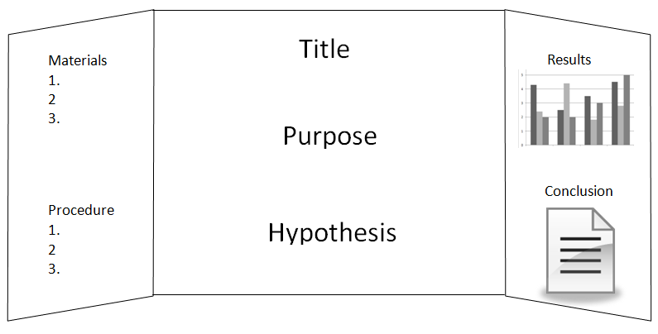

You may add photos to Option 1 as well. Make sure all photos have captions that explain what is occurring in the photo.

Option 2:
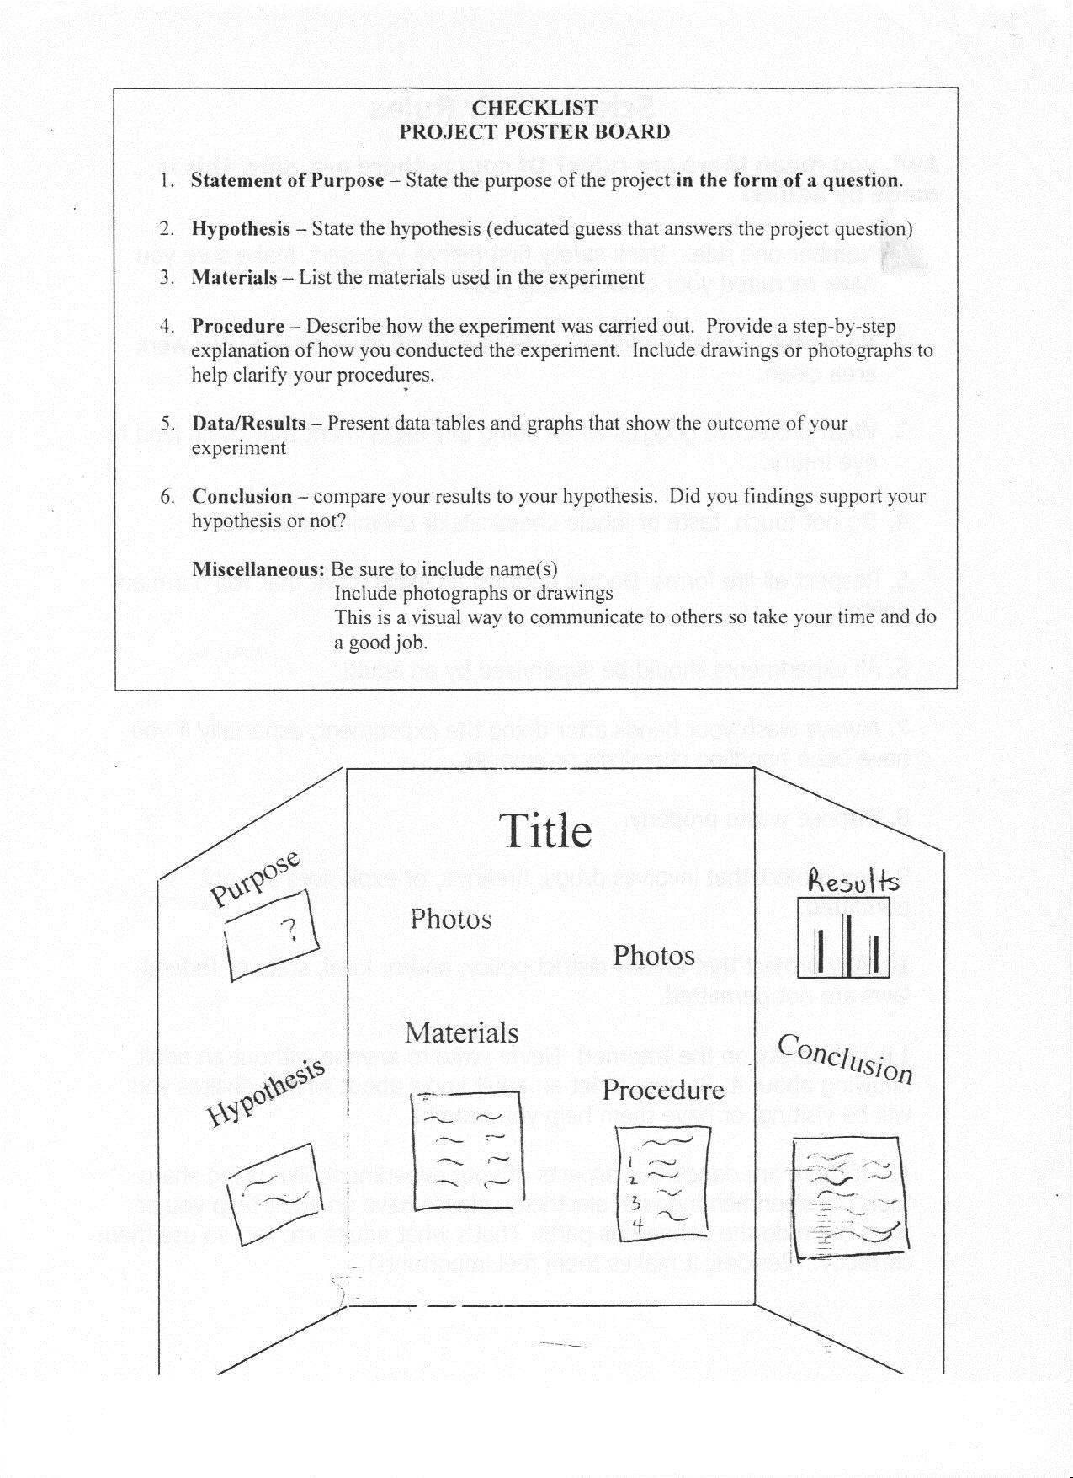Project Planning Sheet
Topic: (Draws audience in)

Question /Statement of Purpose (Written as a Question)

Hypothesis: (If......, then format)

Materials I will need: (needs to be listed using bullets)

Procedure I will use to conduct experiment: (needs to be numbered)

Science Fair Written Report
The written report is a summary of everything that you did to investigate your topic. The written report provides others with vital information on what your project is about as well as its effect on your understanding of the topic. Usually the written report is 5-30 pages in length. All information must be included in the written report. This report provides you with the opportunity to think about all the aspects of our project and share your ideas with others.
- Reports should be neatly bounded in an attractive binder
- Written Report must be typed
- Each item needs it’s own page!
- Include page numbers
- Remember to put headings/titles on graphs/charts/tables
- All photographs must have captions explaining their significance
- Before you hand in your report make sure to reread, revise, and rewrite

All written report for a science fair project should include:
 Title Page: The first page in the report should include the title of the project as well as the name and grade of the student.

 Acknowledgment: Here is where you thank everyone who helped to make your project successful (including Mom and Dad.) Everyone that you interviewed, including teachers, scientists, and other experts in the field should be mentioned in the Acknowledgement page.

 Table of Content: This page provides the reader with a list of the different parts of the project and the page number on which each section can be found.

 Statement of Purpose: State the purpose of the project in the form of a question.

 Hypothesis: You must have a hypothesis before you complete the project. A hypothesis is an educated guess about what you think will occur as a result from completing your experiment. Usually a if/then statement.
 Research Paper: This is the part of the report that contains all the background information that you collected about your topic. Any books or articles read from the internet/journal, authorities on the topic that you talked to, or outside materials collected should be summarized in this section. This paper should be written in your own words and NOT copied directly from your resources. The Research Paper needs to be 2-3 pages, Times New Roman, Size 12 Font, Double Spaced, 1-inch margins, and all sources must be cited in MLA Format on the Reference Page.

 Materials: This is a list of all the materials and supplies used in the project. Quantities and amounts of each should also be indicated. Needs to be numbered or bulleted.

 Procedure: You will list and describe the steps you took to complete the experiment. Usually this is listed in a numbered sequence. This part shows the stages of the project so that another person can carry out the experiment. Be very clear and detailed!

 Observations and Results: In this section, you will tell what you learned from the project. It is also IMPORTANT to include all graphs, charts, or other visual data (pictures) that helps to show your results. Be sure to include a small description under each chart/graph!

 Conclusion: This is a brief statement explaining why your project turned out the way it did. You should explain why the events you observed occurred. Using the word “because” is a good way to turn an observation into a conclusion. The conclusion should tell whether the hypothesis was proven or not proven. Also give the reason(s) why you chose to learn more about the subject. You could also add what you know now that you didn’t know before you completed your project.

 Reference Page: The bibliography should list all the materials the student used to carry out the project. Items should be listed in alphabetical order in a standard MLA format. These website are a great place to go to find the proper way of writing a bibliography. http://www.bibme.org/ , http://www.easybib.com or http://www.knightcite.com Also http://www.Icyte.com lets you “tag” information from Internet sources as you research.
Science Fair Oral Presentation
Relax, smile, and have fun. Remember, you are the expert and you had fun doing the project. But if you are a little nervous, we listed some things that you need to do during the presentation.
Helpful Hints:
o Look sharp, feel sharp, and you will be sharp. Dress nice that day, be polite, and speak clearly. You will show that you have confidence. Don’t forget to look at your audience.
o Introduce yourself. Point to the title of your display. Tell your audience why you chose to study this. o State your problem that you studied (your question.) Tell them about your hypothesis (what you thought might happen.)
o Talk about what you learned while researching your topic.
o Talk about the sources (books, websites, and interviews) that helped you understand your topic.
o Tell about your project and explain the steps you took to conduct your experiment. Be sure to mention all the materials involved and point out the pictures that you may have taken.
o If it applies, be sure to show them that you tested your experiment at least 3 times.
o Show them all of the cool graphic organizers that you made, like your tables and charts. Remember to point out the labeled parts of your graph or table to show that you know what it represents.
o Be sure to explain what your data means. Make sure you can read your graphs and tables. Let them know if you were surprised by the results, or if you know what would happen because you studied about it.
o Make sure you sound like an expert on your topic. Always use the appropriate vocabulary especially by using words from the Scientific Method, like: Problem, Hypothesis, Procedure, Results, and Conclusions.

Written Report Checklist
Due Date | Component | Completed
09/7/18 | Title Page: The first page in the report should include the title of the project as well as the name and grade of the student.
12/3/18 | Acknowledgement Page: The second page in the report should thank all individuals who assisted in the project.
12/3/18 | Table of Contents: This page provides the reader with a list of the different parts of the project and the page number on which each section can be found.
09/7/18 | The Purpose: State your purpose as a question or a statement. What is it you that you want to find out by doing this project?
09/7/18 | Hypothesis: State your hypothesis. What do you think is going to happen? Based on what you know or found out, what do you think the results of your experiment will be? After doing the experiment, it may turn out that your guess was wrong. It’s okay if this happens.
11/16/18 | Research Paper: This is part of the report that contains all the background information the student collected about the chosen topic. All gathered information should be summarized and presented in this section. It should be written in the student’s own words and not copied from the source.
09/28/18 | Materials: List all materials that were used in your experiment. Include exact quantities for each item used.
09/28/18 | Procedures of Investigation: List and describe steps taken to complete the project. Presented in chronological order or numbered order.
11/2/18 | Results: Tell what happened when you did the experiment. Show what happened by making a chart, graph, or table. Include the date, the time, and any other useful information. Write all measurements clearly.
11/2/18 | Conclusion: This is a brief statement explaining why a project turned out the way it did. Students should explain why the events they observed occurred. The conclusion should tell whether the hypothesis was proven or not proven. It should offer an answer to the student’s original purpose.
11/16/18 | Reference Page: In alphabetical order, list all the resources that you used to research your project. Correct format was used.
12/3/18 | Conventions: Proper use of spelling, grammar, punctuation, and capitalization. MUST be typed.

Display Board Check List
Due Date | Component | Completed
12/5/18 | Title: Does the title catch people’s attention and is it large enough to be read from across the room?
12/5/18 | Purpose
12/5/18 | Hypothesis
12/5/18 | Procedures of Investigation
12/5/18 | Materials
12/5/18 | Results/ Graphs/ Charts: Did the student use pictures and diagrams to effectively convey information about the project?
12/5/18 | Conclusion
12/5/18 | Conventions: Proper use of spelling, grammar, punctuation, and capitalization on all elements on the display board.
12/5/18 | Neatness
12/5/18 | Organization: Are the sections on the display board organized like a newspaper so they are easy to follow?

Oral Presentation Check List
Due Date | Component | Completed
12/5/18 | Introduction: Student introduces himself and gives the title of the project.
12/5/18 | Statement of Purpose/ Hypothesis
12/5/18 | Explanation of Procedure
12/5/18 | Explanation of Results/Charts and Graphs
12/5/18 | Conclusion
12/5/18 | Good Posture and Eye Contact
12/5/18 | Speaks Clearly

Helpful Science Fair Websites
- GALILEO is an online library portal to authoritative, subscription-only information that isn’t available through free search engines or Web directories. Subscribers may access over 100 databases indexing thousands of periodicals and scholarly journals. Over 10,000 journal titles are provided in full-text. Click Grades 6-8 Teen http://www.wesleyacademy.org/academics/media-center/galileo/

- Citing Sources- MLA Format https://owl.english.purdue.edu/owl/resource/747/01/

- Google Scholar- https://scholar.google.com

- Science Buddies: Use the topic selection wizard to help you figure out what science projects interest you most. Once you have a topic, get help doing research, setting up the experiments, and completing them. http://www.sciencebuddies.org/

- Science Fair Central: Includes cool project ideas, a science fair handbook, reviews of students' experiments, and more from Discovery Channel School. http://school.discovery.com/sciencefaircentral/

- Super Science Fair Projects: Guide to projects, topics, experiments, and tips for successfully completing a science project, including the six steps of the Scientific Method. http://www.super-science-fair-projects.com/

